**JAVASCRIPT/JQUERY/AJAX/JS FRAMEWORKS & LIBRARIES GUIDES**

1. Array

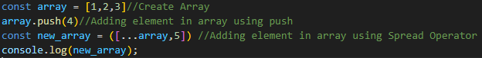

1. Class

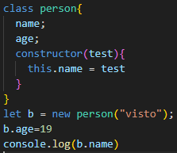

1. Function

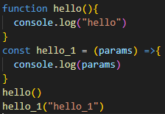

1. Jquery

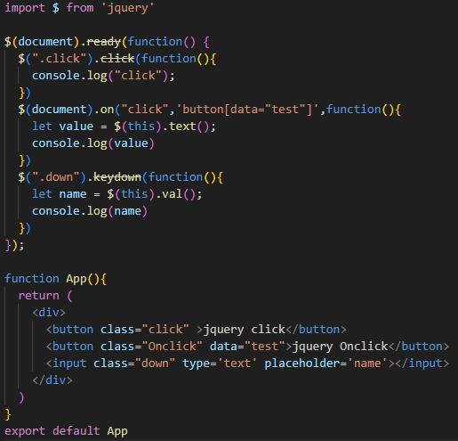

1. Object

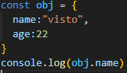

1. Ajax Get

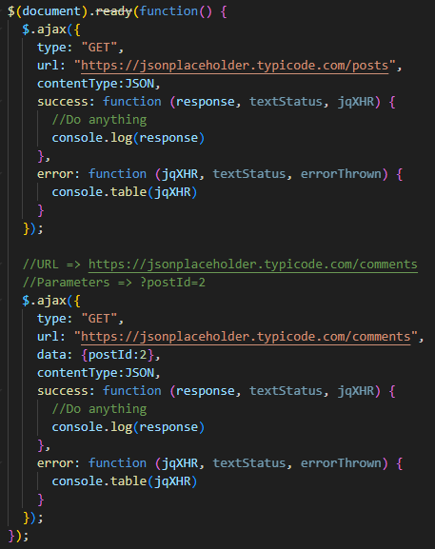

1. Ajax Post

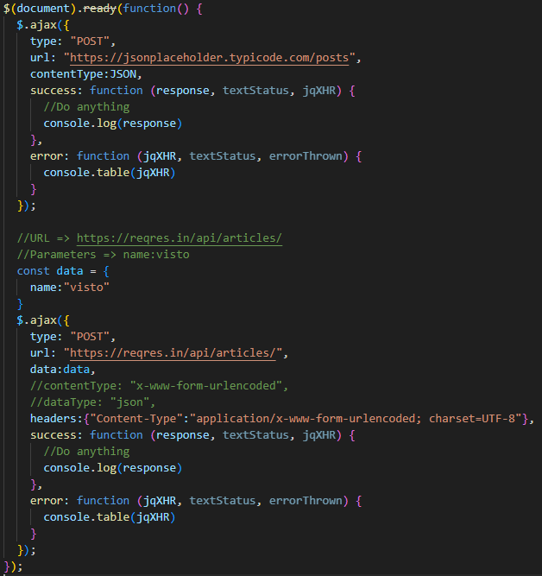

1. Get parameters from URL

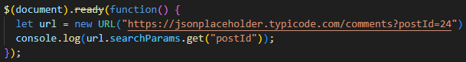

1. Cookie

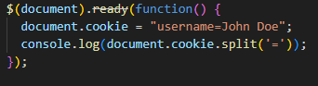

1. File Upload/File Handling
2. Custom Header
3. JSON